Hebrew Numeral System
# Source: AI Source: Provided by: [Data Path: Persons Table -> ID Column: 1, Name_En Column: Motasem Essam] -> From: [ChatGPT] on [7/16/2026]
The Hebrew Numeral System is a non-positional numeral system in which the letters of the Hebrew alphabet are assigned fixed numerical values. Numbers are represented by combining these letters according to additive rules.
This system has been used for over two thousand years in Jewish religious texts, calendars, manuscripts, inscriptions, legal documents, and traditional numbering.
Unlike positional numeral systems such as decimal or binary, the Hebrew numeral system does not use place value or a base (radix).

Definition
# Source: AI Source: Provided by: [Data Path: Persons Table -> ID Column: 1, Name_En Column: Motasem Essam] -> From: [ChatGPT] on [7/16/2026]
The Hebrew Numeral System is a non-positional numeral system that assigns fixed numerical values to the letters of the Hebrew alphabet.
Numbers are represented by combining letters, and the total value is obtained by adding the values of the individual letters.

Type of Numeral System
# Source: AI Source: Provided by: [Data Path: Persons Table -> ID Column: 1, Name_En Column: Motasem Essam] -> From: [ChatGPT] on [7/16/2026]
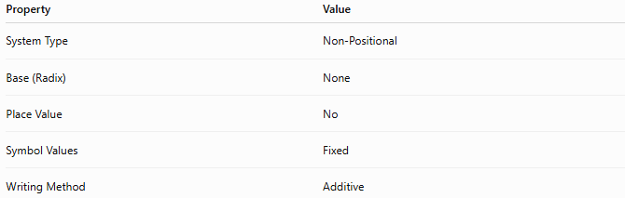
Property | Value
System Type | Non-Positional
Base (Radix) | None
Place Value | No
Symbol Values | Fixed
Writing Method | Additive

Basic Principle
# Source: AI Source: Provided by: [Data Path: Persons Table -> ID Column: 1, Name_En Column: Motasem Essam] -> From: [ChatGPT] on [7/16/2026]
Each Hebrew letter represents a fixed numerical value.
Numbers are formed by:
- Selecting the appropriate letters.
- Adding their numerical values.
The position of a letter does not change its value.

Hebrew Numeral Values

Units
# Source: AI Source: Provided by: [Data Path: Persons Table -> ID Column: 1, Name_En Column: Motasem Essam] -> From: [ChatGPT] on [7/16/2026]
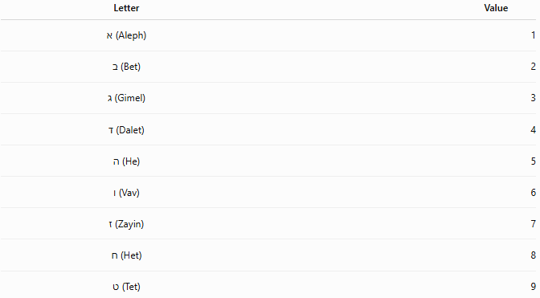
Letter | Value
א (Aleph) | 1
ב (Bet) | 2
ג (Gimel) | 3
ד (Dalet) | 4
ה (He) | 5
ו (Vav) | 6
ז (Zayin) | 7
ח (Het) | 8
ט (Tet) | 9

Tens
# Source: AI Source: Provided by: [Data Path: Persons Table -> ID Column: 1, Name_En Column: Motasem Essam] -> From: [ChatGPT] on [7/16/2026]
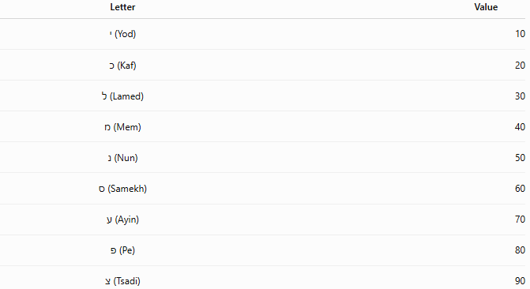
Letter | Value
י (Yod) | 10
כ (Kaf) | 20
ל (Lamed) | 30
מ (Mem) | 40
נ (Nun) | 50
ס (Samekh) | 60
ע (Ayin) | 70
פ (Pe) | 80
צ (Tsadi) | 90

Hundreds
# Source: AI Source: Provided by: [Data Path: Persons Table -> ID Column: 1, Name_En Column: Motasem Essam] -> From: [ChatGPT] on [7/16/2026]
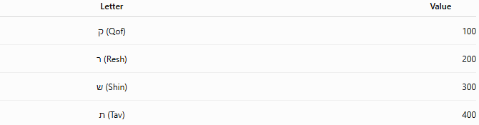
Letter | Value
ק (Qof) | 100
ר (Resh) | 200
ש (Shin) | 300
ת (Tav) | 400
Values greater than 400 are formed by combining letters.
Example:
$$500=\text{תק}=400+100$$

Writing Numbers
# Source: AI Source: Provided by: [Data Path: Persons Table -> ID Column: 1, Name_En Column: Motasem Essam] -> From: [ChatGPT] on [7/16/2026]
Numbers are formed by adding the values of the letters.

Example 1
Number
$$18$$
Normally,
$$10+8$$
would be
$$\text{יח}$$
However, in Hebrew tradition, 15 and 16 are written differently (see Special Rules below).

Example 2
Number
$$27$$
Representation
$$\text{כז}$$
Calculation
$$20+7=27$$

Example 3
Number
$$345$$
Representation
$$\text{שמה}$$
Calculation
$$300+40+5=345$$

Example 4
Number
$$5786$$
Often written (omitting the thousands digit, as is customary in many contexts):
$$\text{תשפ״ו}$$
This represents
$$400+300+80+6=786$$
with the millennium (5000) understood from the context.

Special Writing Rules
# Source: AI Source: Provided by: [Data Path: Persons Table -> ID Column: 1, Name_En Column: Motasem Essam] -> From: [ChatGPT] on [7/16/2026]
Numbers 15 and 16
The numbers 15 and 16 are not written in the expected additive form because that would spell combinations of letters associated with the Divine Name.
Instead:

Number | Standard Form
15 | ט״ו = 9 + 6
16 | ט״ז = 9 + 7
rather than
- יה (10 + 5)
- יו (10 + 6)

Punctuation Marks
# Source: AI Source: Provided by: [Data Path: Persons Table -> ID Column: 1, Name_En Column: Motasem Essam] -> From: [ChatGPT] on [7/16/2026]
Hebrew numerals commonly use punctuation marks:
Geresh (׳)
Placed after a single letter numeral.
Example:
$$\text{א׳}=1$$

Gershayim (״)
# Source: AI Source: Provided by: [Data Path: Persons Table -> ID Column: 1, Name_En Column: Motasem Essam] -> From: [ChatGPT] on [7/16/2026]
Placed before the final letter of a multi-letter numeral.
Example:
$$\text{כ״ז}=27$$

Characteristics
# Source: AI Source: Provided by: [Data Path: Persons Table -> ID Column: 1, Name_En Column: Motasem Essam] -> From: [ChatGPT] on [7/16/2026]
The Hebrew numeral system:
- Is non-positional.
- Uses Hebrew alphabet letters.
- Assigns fixed values to letters.
- Uses additive notation.
- Has no place value.
- Has no positional base.

Zero
# Source: AI Source: Provided by: [Data Path: Persons Table -> ID Column: 1, Name_En Column: Motasem Essam] -> From: [ChatGPT] on [7/16/2026]
The traditional Hebrew numeral system does not include a symbol for zero.

Negative Numbers
# Source: AI Source: Provided by: [Data Path: Persons Table -> ID Column: 1, Name_En Column: Motasem Essam] -> From: [ChatGPT] on [7/16/2026]
The Hebrew numeral system was not designed to represent negative numbers.
It was intended primarily for numbering, dating, and religious or administrative purposes.

Advantages
# Source: AI Source: Provided by: [Data Path: Persons Table -> ID Column: 1, Name_En Column: Motasem Essam] -> From: [ChatGPT] on [7/16/2026]
The Hebrew numeral system:
- Is compact.
- Uses familiar alphabetic symbols.
- Is well suited for manuscripts and inscriptions.
- Has remained in continuous use for centuries.

Disadvantages
# Source: AI Source: Provided by: [Data Path: Persons Table -> ID Column: 1, Name_En Column: Motasem Essam] -> From: [ChatGPT] on [7/16/2026]
The Hebrew numeral system:
- Does not use place value.
- Has no zero.
- Makes arithmetic calculations difficult.
- Requires knowledge of alphabetic values.
- Is unsuitable for modern scientific computation.

Applications
# Source: AI Source: Provided by: [Data Path: Persons Table -> ID Column: 1, Name_En Column: Motasem Essam] -> From: [ChatGPT] on [7/16/2026]
The Hebrew numeral system is used in:
- Jewish calendars
- Religious texts
- Bible references
- Chapter numbering
- Page numbering
- Legal documents
- Historical inscriptions
- Memorial plaques
- Traditional manuscripts
- Gematria (assigning numerical values to words for interpretive purposes)

Real-Life Applications
# Source: AI Source: Provided by: [Data Path: Persons Table -> ID Column: 1, Name_En Column: Motasem Essam] -> From: [ChatGPT] on [7/16/2026]
Examples include:
- Hebrew calendar years
- Torah chapter references
- Psalm numbering
- Jewish holidays and commemorations
- Synagogue inscriptions
- Religious publications

Common Mistakes
# Source: AI Source: Provided by: [Data Path: Persons Table -> ID Column: 1, Name_En Column: Motasem Essam] -> From: [ChatGPT] on [7/16/2026]
- Assuming the system uses place value.
- Forgetting the special forms for 15 and 16.
- Treating Hebrew letters as positional digits.
- Assuming the system has a base like decimal or binary.

Key Points
# Source: AI Source: Provided by: [Data Path: Persons Table -> ID Column: 1, Name_En Column: Motasem Essam] -> From: [ChatGPT] on [7/16/2026]
- The Hebrew numeral system is non-positional.
- Hebrew letters represent fixed numerical values.
- Numbers are formed by adding letter values.
- The original system has no zero.
- It remains in active use in religious, historical, and cultural contexts.

Hebrew Numeral System vs. Decimal System
# Source: AI Source: Provided by: [Data Path: Persons Table -> ID Column: 1, Name_En Column: Motasem Essam] -> From: [ChatGPT] on [7/16/2026]
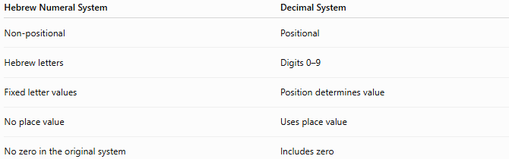
Hebrew Numeral System | Decimal System
Non-positional | Positional
Hebrew letters | Digits 0–9
Fixed letter values | Position determines value
No place value | Uses place value
No zero in the original system | Includes zero

Hebrew Numeral System vs. Greek Numeral System
# Source: AI Source: Provided by: [Data Path: Persons Table -> ID Column: 1, Name_En Column: Motasem Essam] -> From: [ChatGPT] on [7/16/2026]
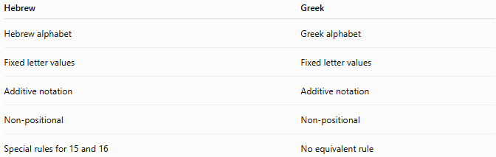
Hebrew | Greek
Hebrew alphabet | Greek alphabet
Fixed letter values | Fixed letter values
Additive notation | Additive notation
Non-positional | Non-positional
Special rules for 15 and 16 | No equivalent rule

Hebrew Numeral System vs. Roman Numerals
# Source: AI Source: Provided by: [Data Path: Persons Table -> ID Column: 1, Name_En Column: Motasem Essam] -> From: [ChatGPT] on [7/16/2026]
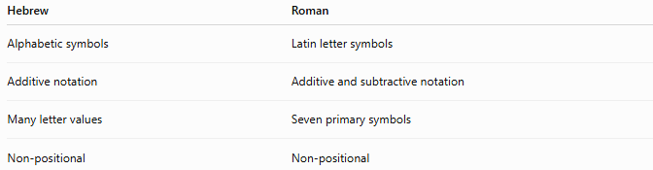
Hebrew | Roman
Alphabetic symbols | Latin letter symbols
Additive notation | Additive and subtractive notation
Many letter values | Seven primary symbols
Non-positional | Non-positional

Conclusion
# Source: AI Source: Provided by: [Data Path: Persons Table -> ID Column: 1, Name_En Column: Motasem Essam] -> From: [ChatGPT] on [7/16/2026]
The Hebrew Numeral System is a non-positional numeral system that assigns fixed numerical values to the letters of the Hebrew alphabet. Numbers are formed by adding the values of the letters, without using place value or a positional base. The system has been used for centuries in Jewish calendars, religious texts, legal documents, and historical records. While it has largely been replaced by positional numeral systems for arithmetic and scientific work, it remains an important cultural, historical, and religious numbering system.

